**PROGRAMMING IN JAVA PROJECT ON THE DEVELOPMENT OF**

**A HOTEL MANAGEMENT SYSTEM DESKTOP APPLICATION**

Developed by

Name: **SABA, AYODELE SHAMSUDEEN**

Start Date : November 26, 2019

End Date : December 20th, 2019

Name of the Coordinator : Mr Nelson

Name of Developer : Saba, Ayodele

Date of submission : January 31st, 2020

**CERTIFICATE**

This is to certify that this report on the development of the University of NIIT website embodies the original work done by **Saba Ayodele** in partial fulfillment of their course requirement at NIIT.

Coordinator:

*Mr. Nelson*

**ACKNOWLEDGEMENT**

First I want to say Alhamdulillah and thank Almighty Allah for seeing me through the completion of this project. Then I would like to appreciate my uncle for assisting me financially in registration at NIIT. I would also like to appreciate my friends and colleagues in person of Prince, Ahmed, Godwin and everyone else who helped me through this project with ideas and suggestions. Also I want to appreciate my Lecturer Mr. Nelson for the knowledge impacted in me which made it possible for me to do this project.

**INTRODUCTION**

I developed a Hotel Management System for the Hotel named “Shams Hotel” Using NetBeans IDE.

The app developed is a desktop application using Java programming language, also it should be noted that this application was created for use by the Hotel Staffs and Management and not customers.

Also Xampp was used to create a database for this app.

**ACTIVITIES LIST**

The following tasks have been performed to meet the specifications of the project scenario:

1. A login page was created in which both the management and staff of the Hotel can log into the application easily.
2. Two separate welcome pages were created, one if logged in as the Admin and the other if logged in as a member of staff. This welcome pages have different contents
3. Two separate booking page was also created, one for the admin and for staff. On this page customers are booked into the hotel
4. A page was also created where the customer details could be easily edited or deleted
5. A page which holds the records of everyone who has been booked into the hotel was also created.

1. A page for booking Laundry services was created and also a page for booking Restaurant services.
2. A page were staff accounts are signed up was also created.

**PAGES**

1. The following images displays the Login Page of the application.

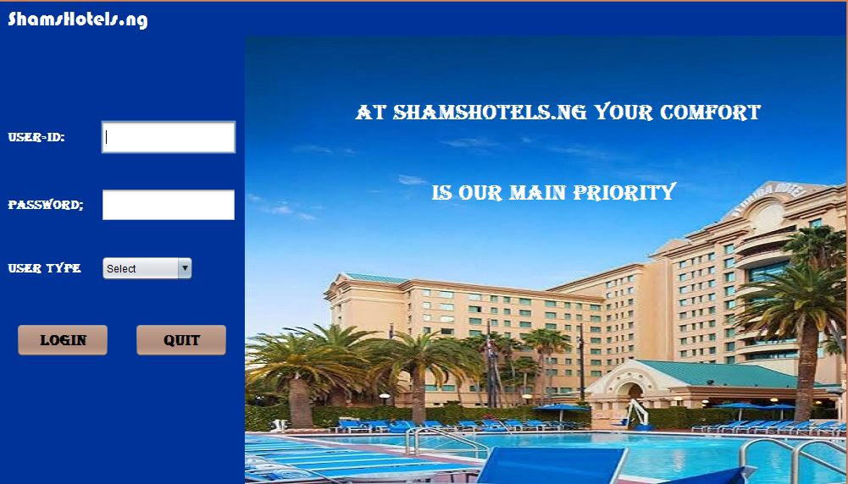

1. The following images displays the Welcome page**.**

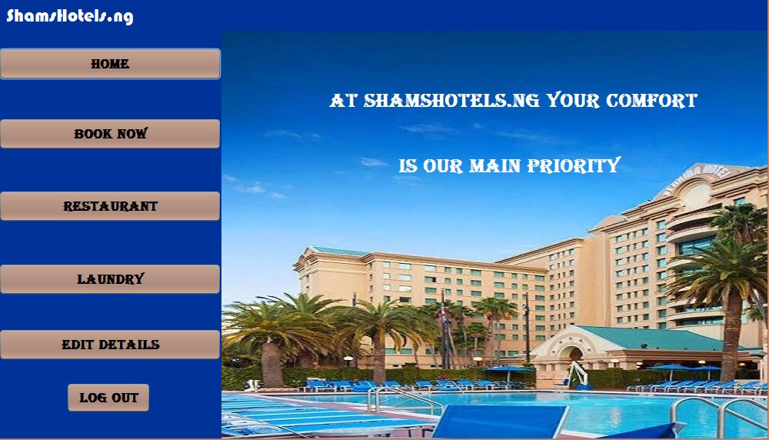

1. The image below displays the Booking page.

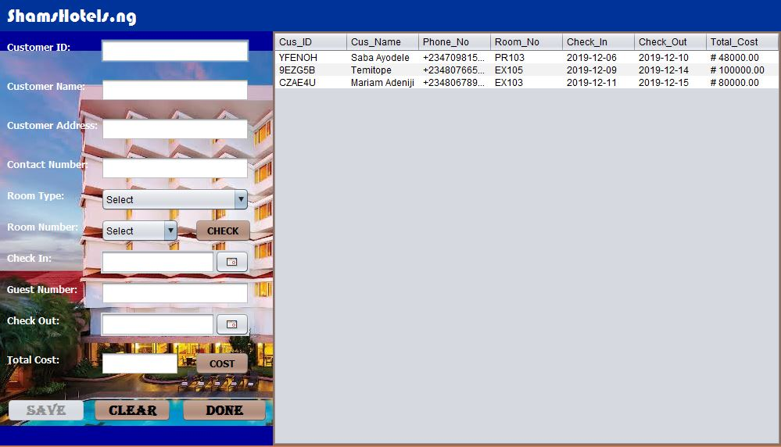

1. The image below displays the Edit details page.

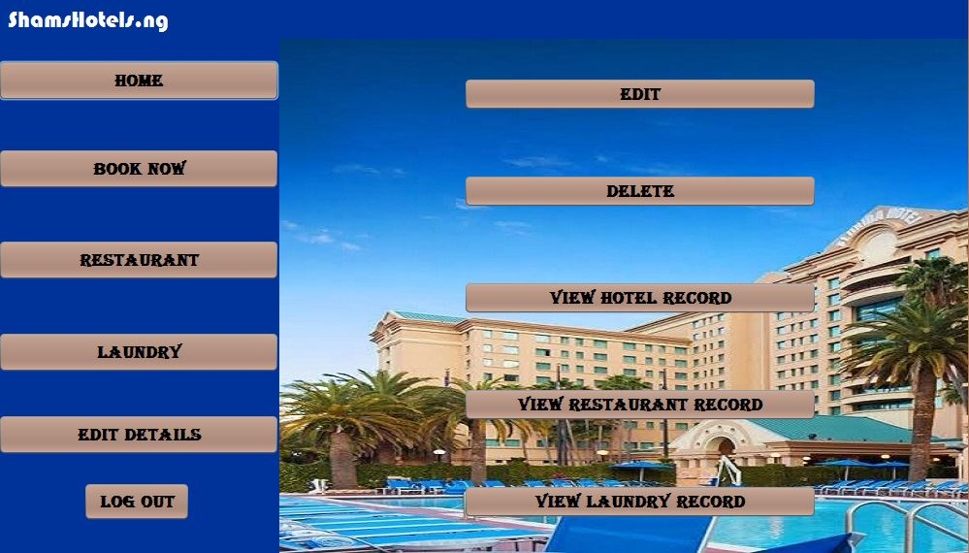

1. The image bellow displays the Restaurant services page

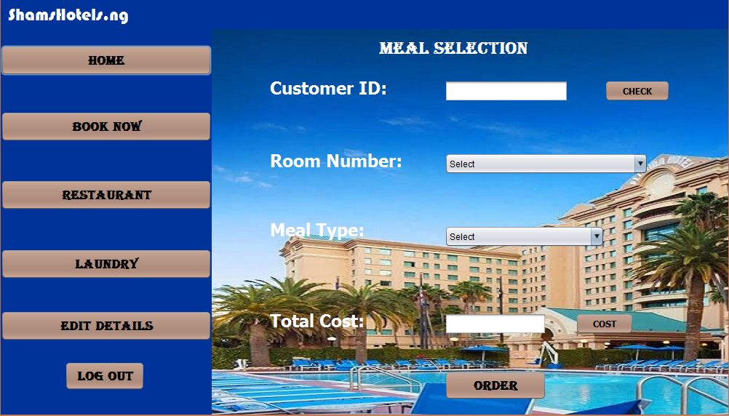

1. The image bellow displays the Laundry services page.

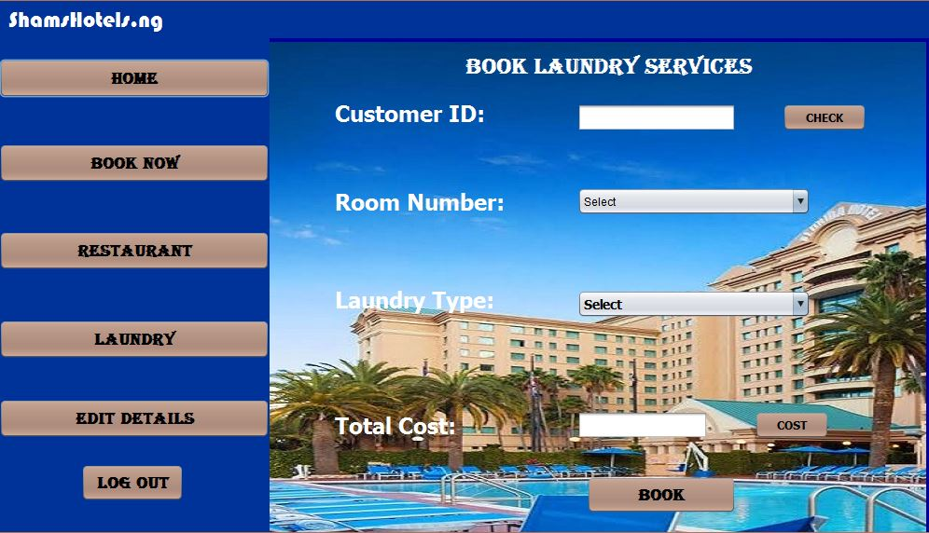

7. The Image bellow shows the View Records Page.

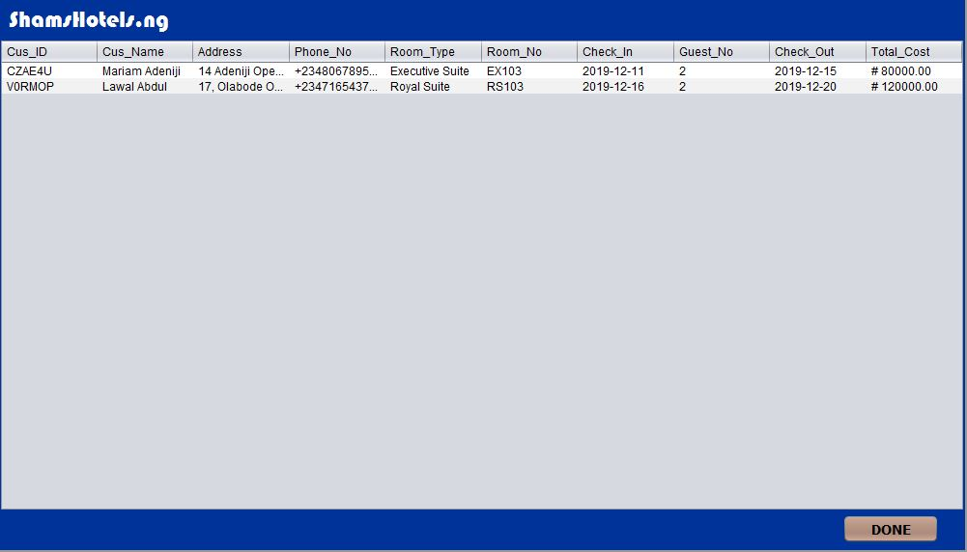

**SYSTEM CONFIGURATION**

**Processor: Intel(R) Pentium(R) CPU N3510 @ 1.99GHz 1.99GHz**, 4GB RAM and 500 GB Hard Disk

**Operating system:** Windows 10, 64-bit Operating system.

**Software:** Sublime text, Mozilla Firefox and Google Chrome.